Agile Development

How to Configure the Api In the local

**Step 1**: Clone the SPMIntegrationAPI From the Git

[SPMIntegrationAPI - Repos (visualstudio.com)](https://uppwise.visualstudio.com/UppwiseSPM/_git/SPMIntegrationAPI)

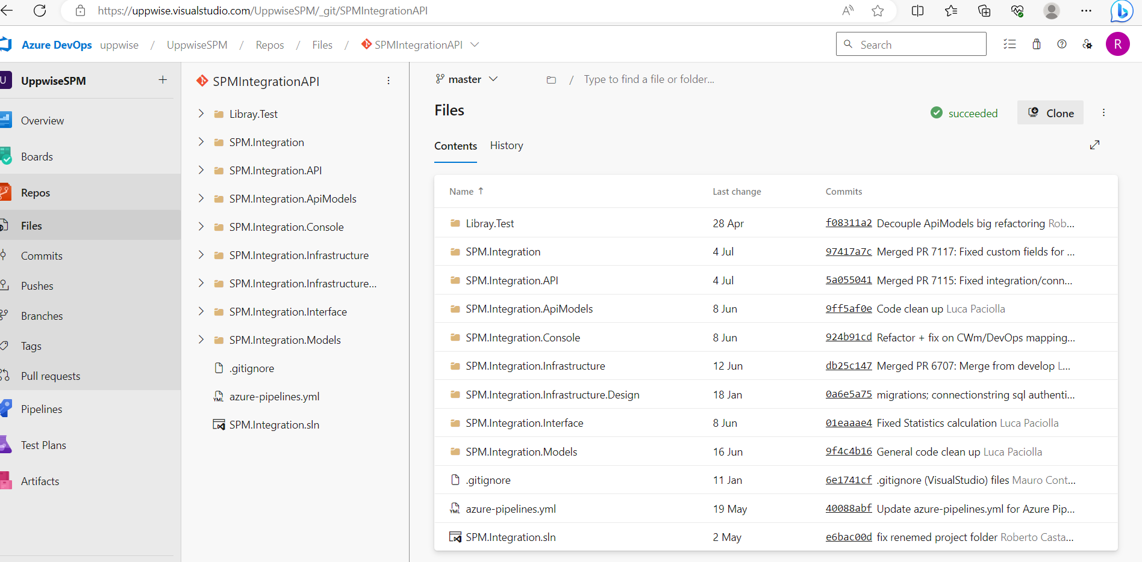

**Step 2** : Open this solution in Visual studio community 2022 as its not supported in 2019

**Step 3** : Now go to the appsettings.development.json File And Do the Configuration changes to run the api

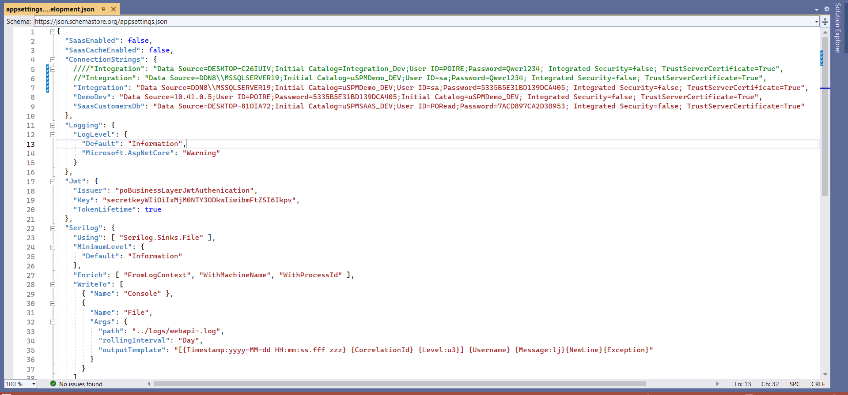

Now Go to the main application

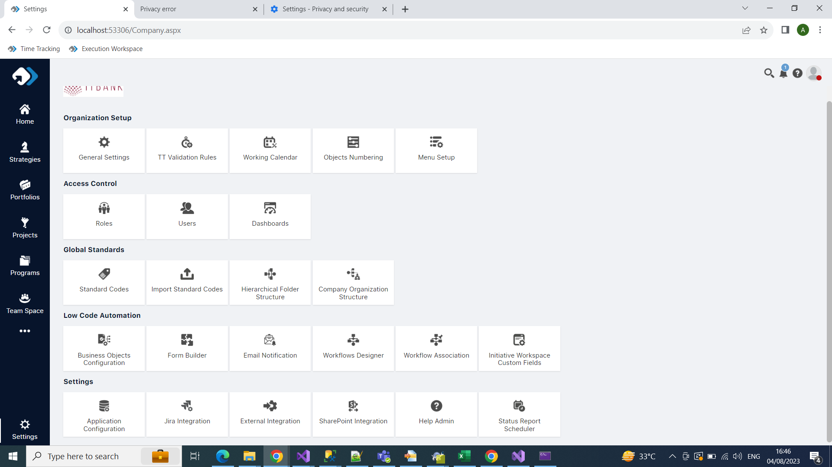

**#** Go to The setting and open up the External Integration

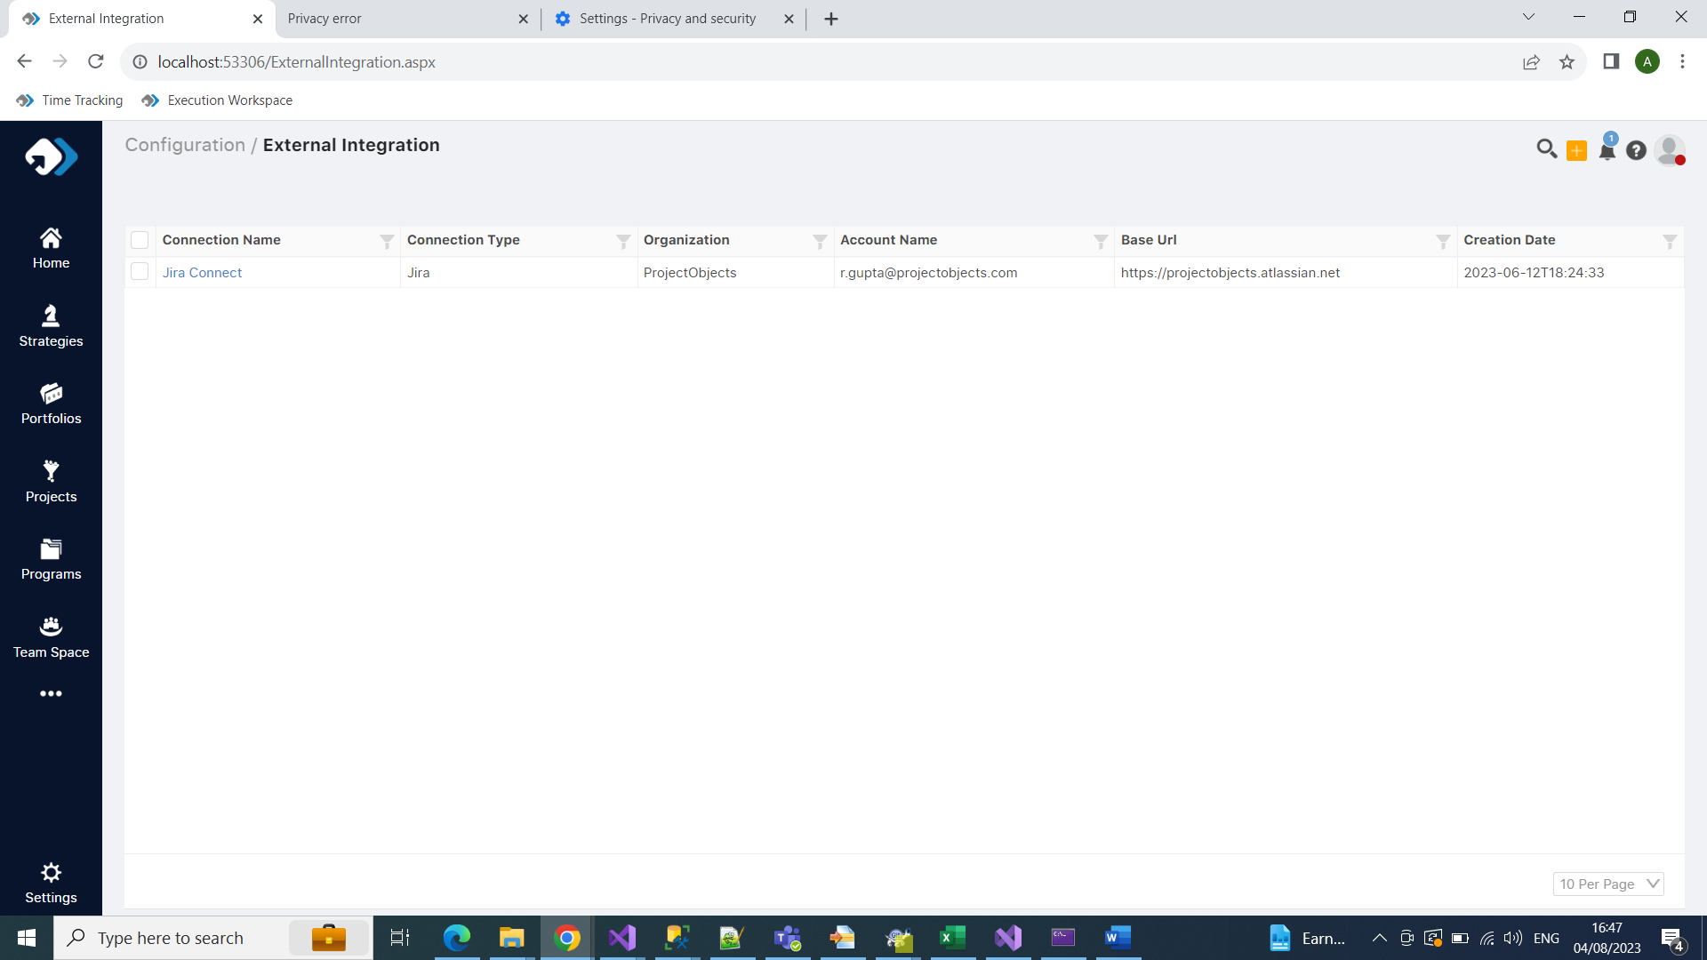

**#** Here Is the list of the connection you have made In the Application

Now the Code Part Where the list is coming

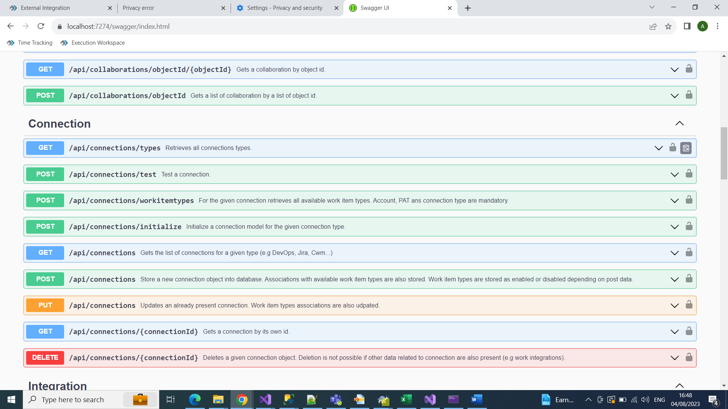

# This is the list of all the api which we are consume for making and showing the connection at admin level



# This is the api which we are consuming for showing the connection

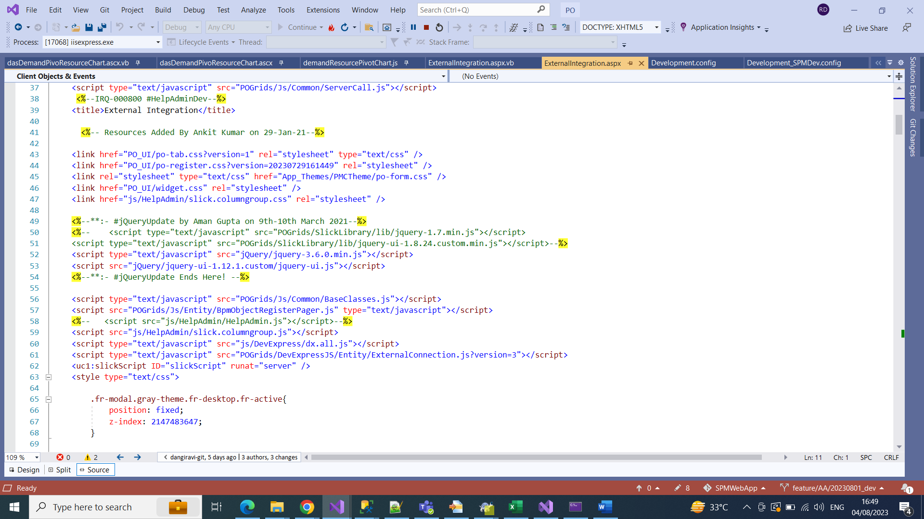

This is the page of the list of connection which we are showing in the admin

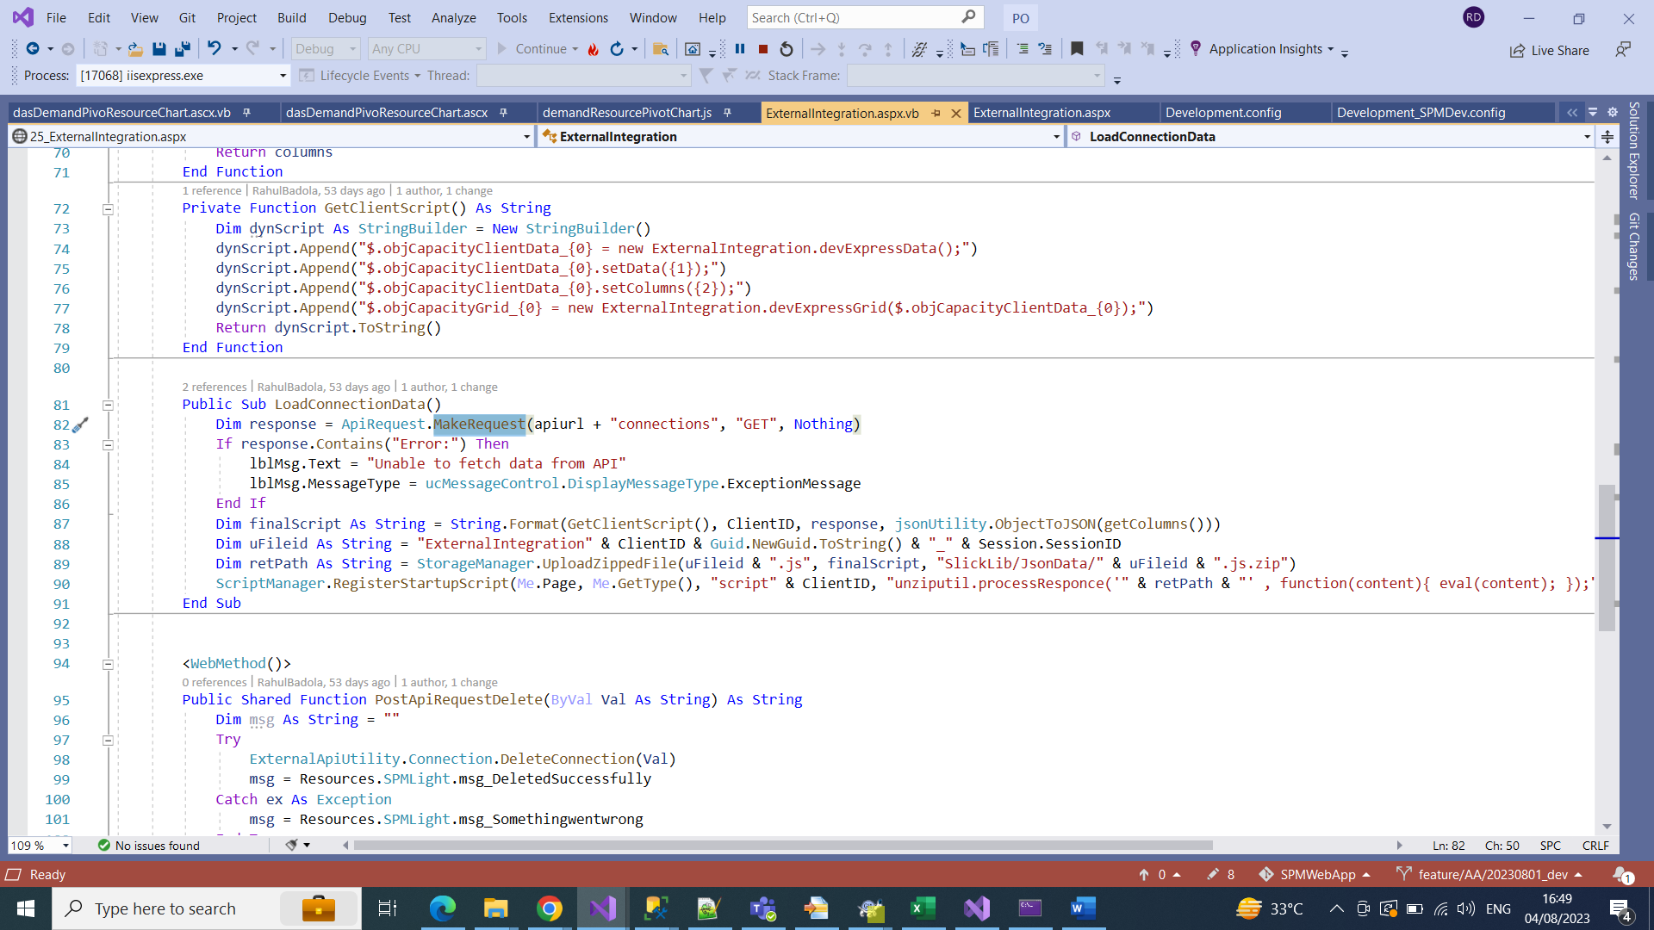

This is the vb side of the page where we are calling the api to fetch the data of list of connection and show it on the page

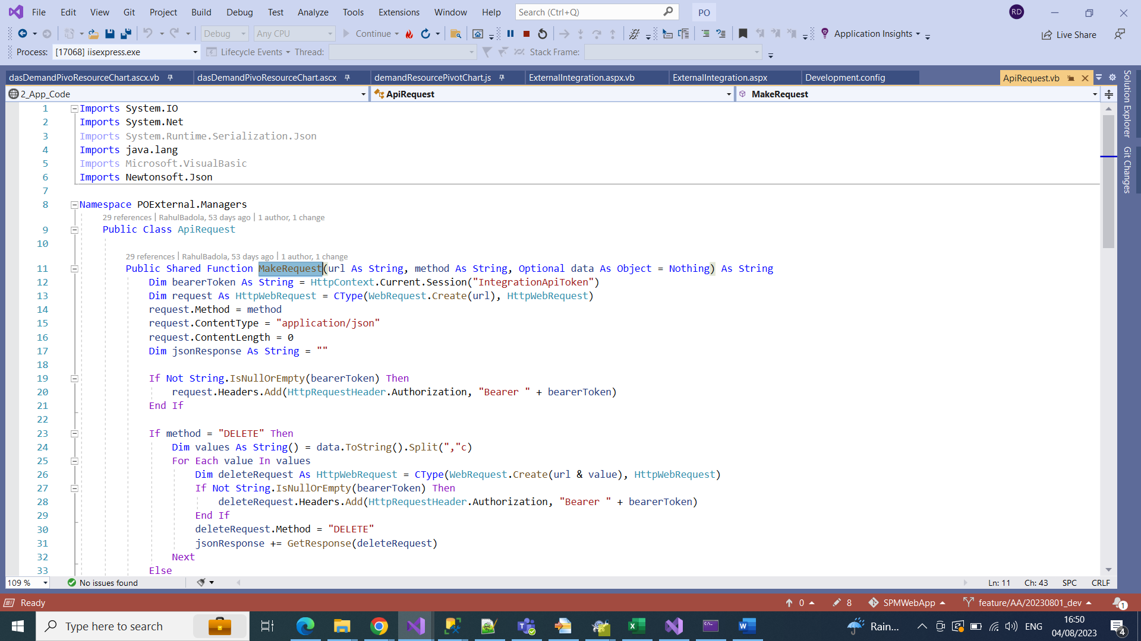

MakeRequets is the common method to call the api for every operation

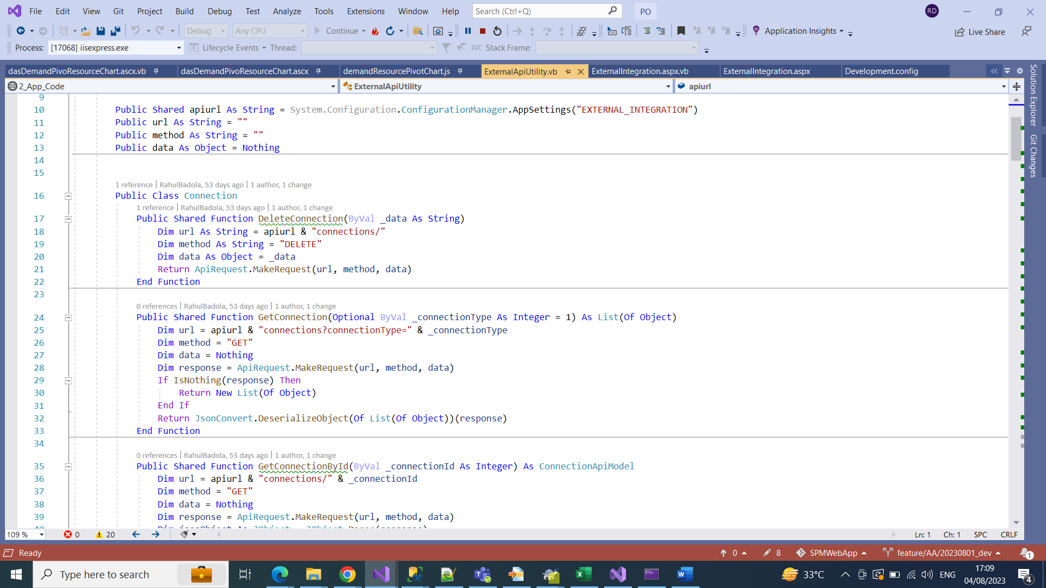

This Vb side contains all the methods to perform all the operation Like to Delete , Add, Get

Now here How to add a connection

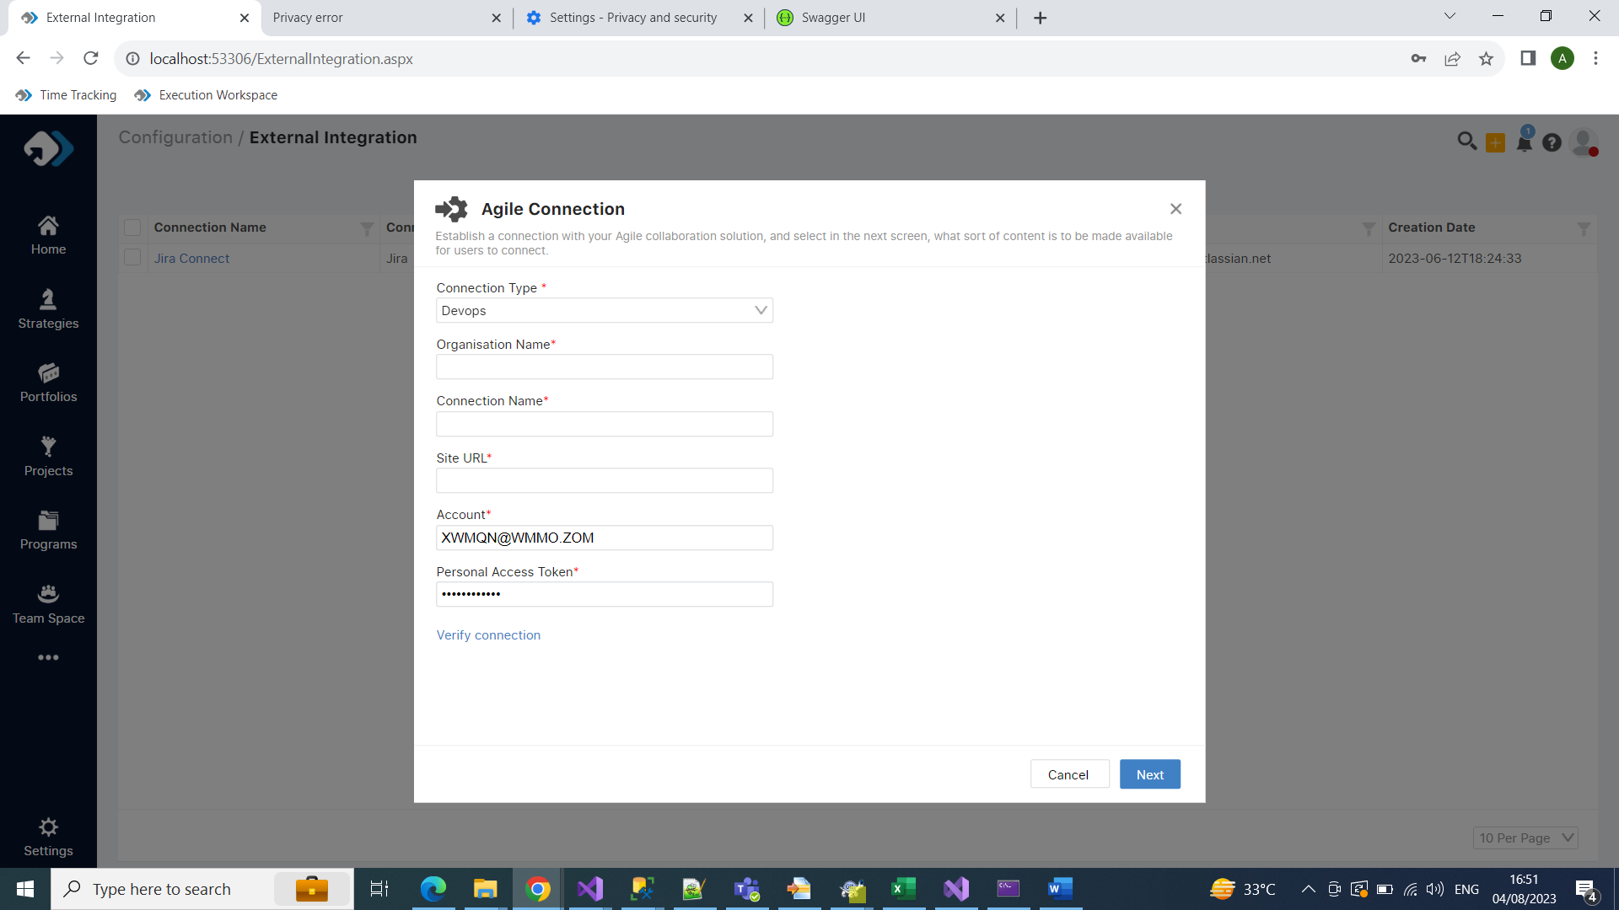

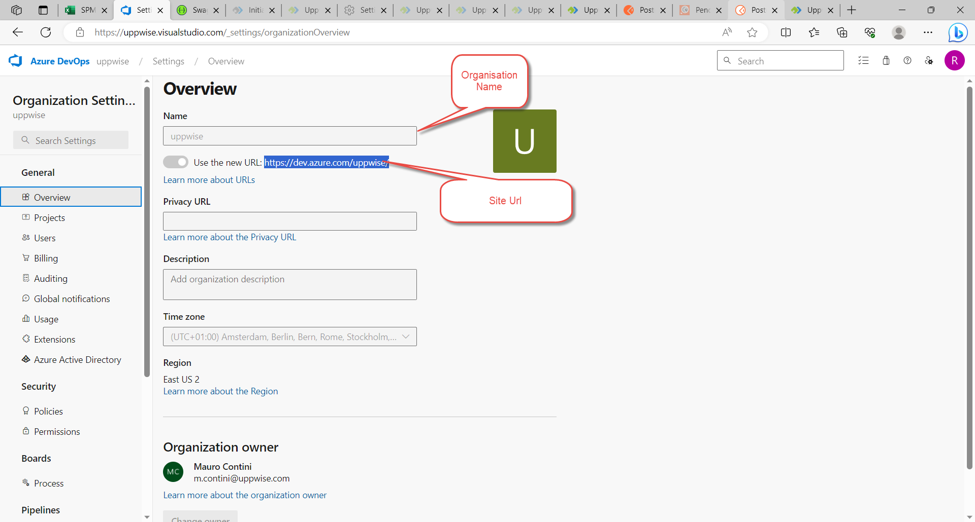

Step to create token

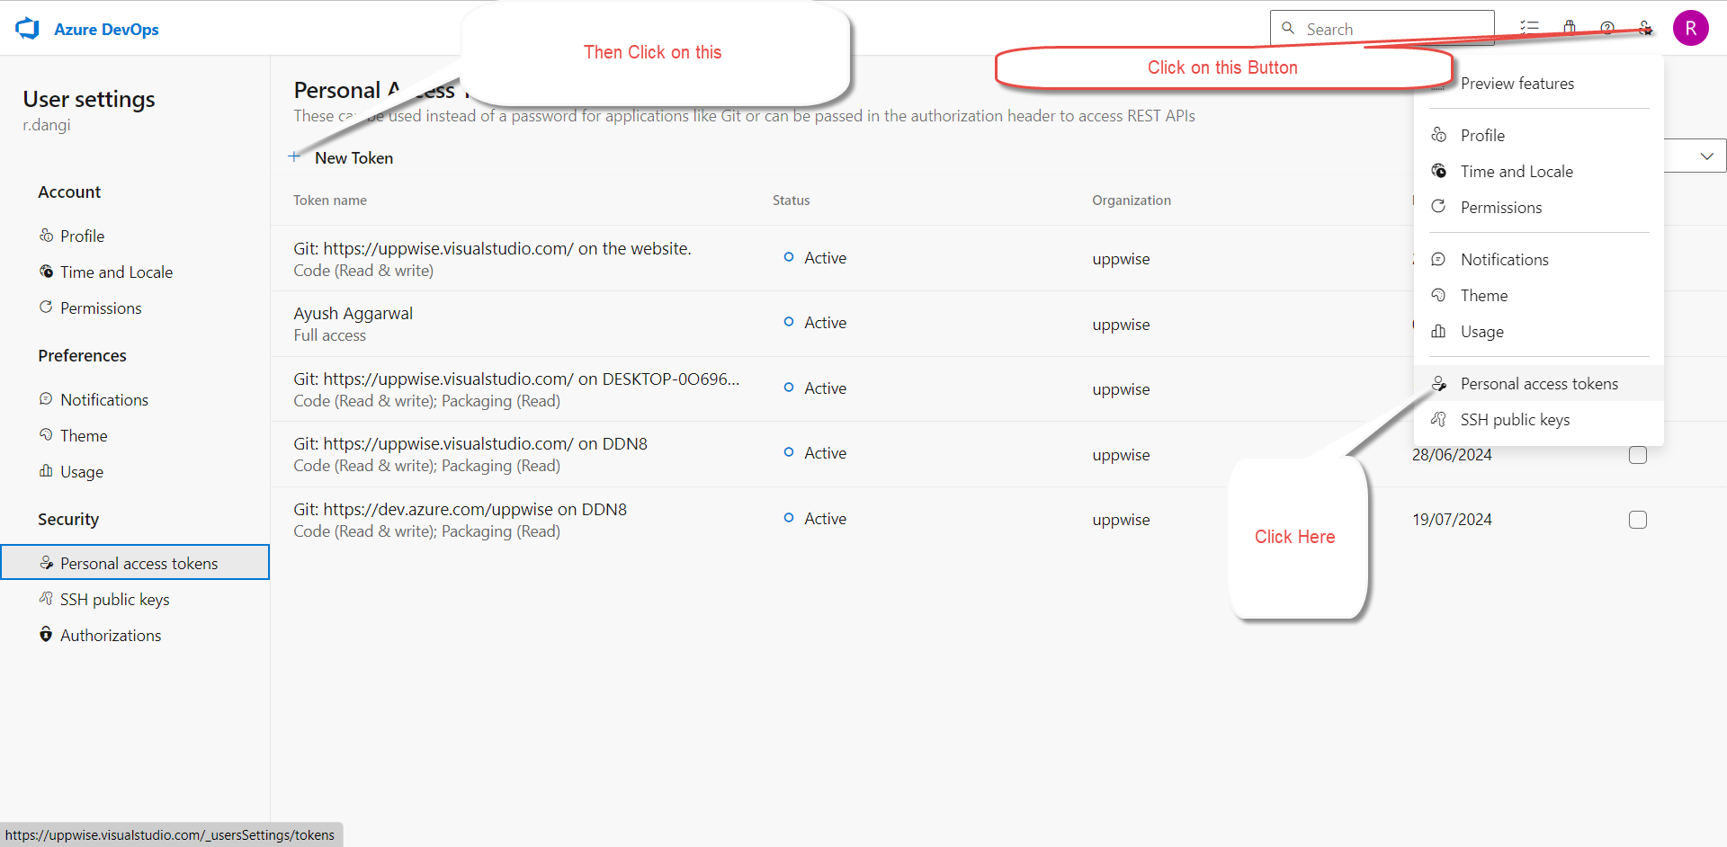

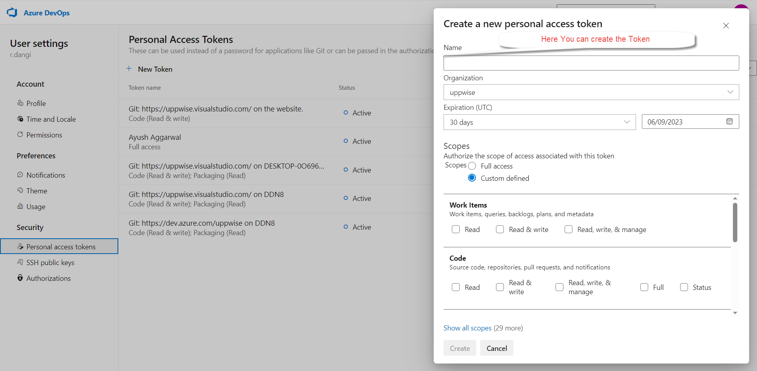

Click on the plus button on the page this popup is come up here you can make the connection by providing the necessary details

Now first click on verify connection to verify the connection if its valid or not

If connection is verify then click on the next button

Then The api/connection/initialize api is called to load the data

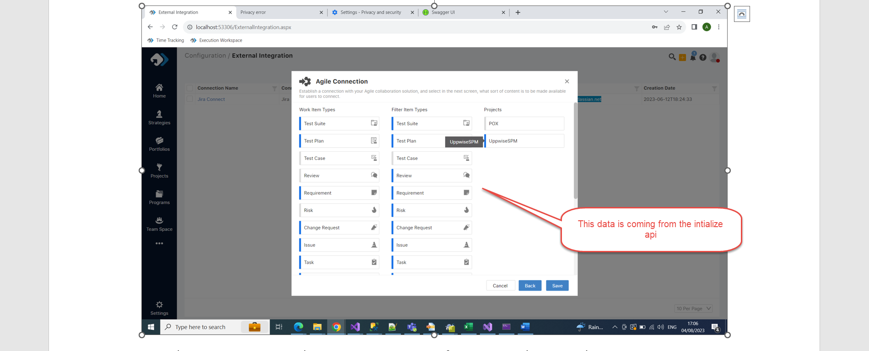

Now this page is come up where You can set you prefernces according your choice

Now comes to the code part

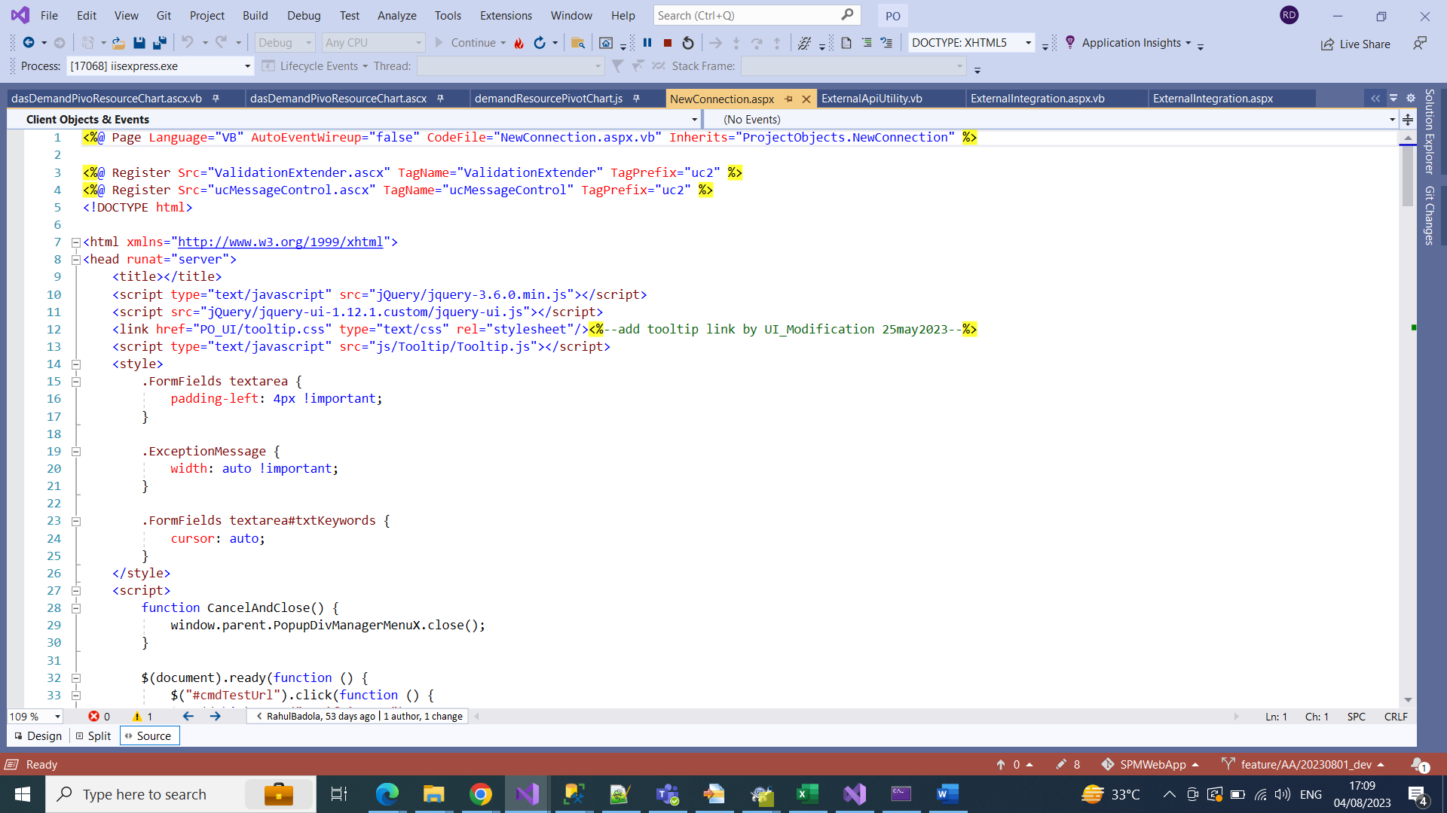

Page of the popup of the new connection



Vb side of the page of the new connection

When the data is saved we can see those data in these below table

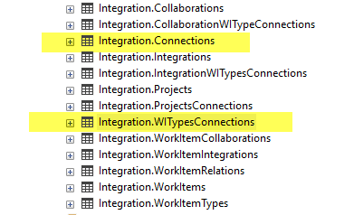

These Highlighted table are shown which data are enter

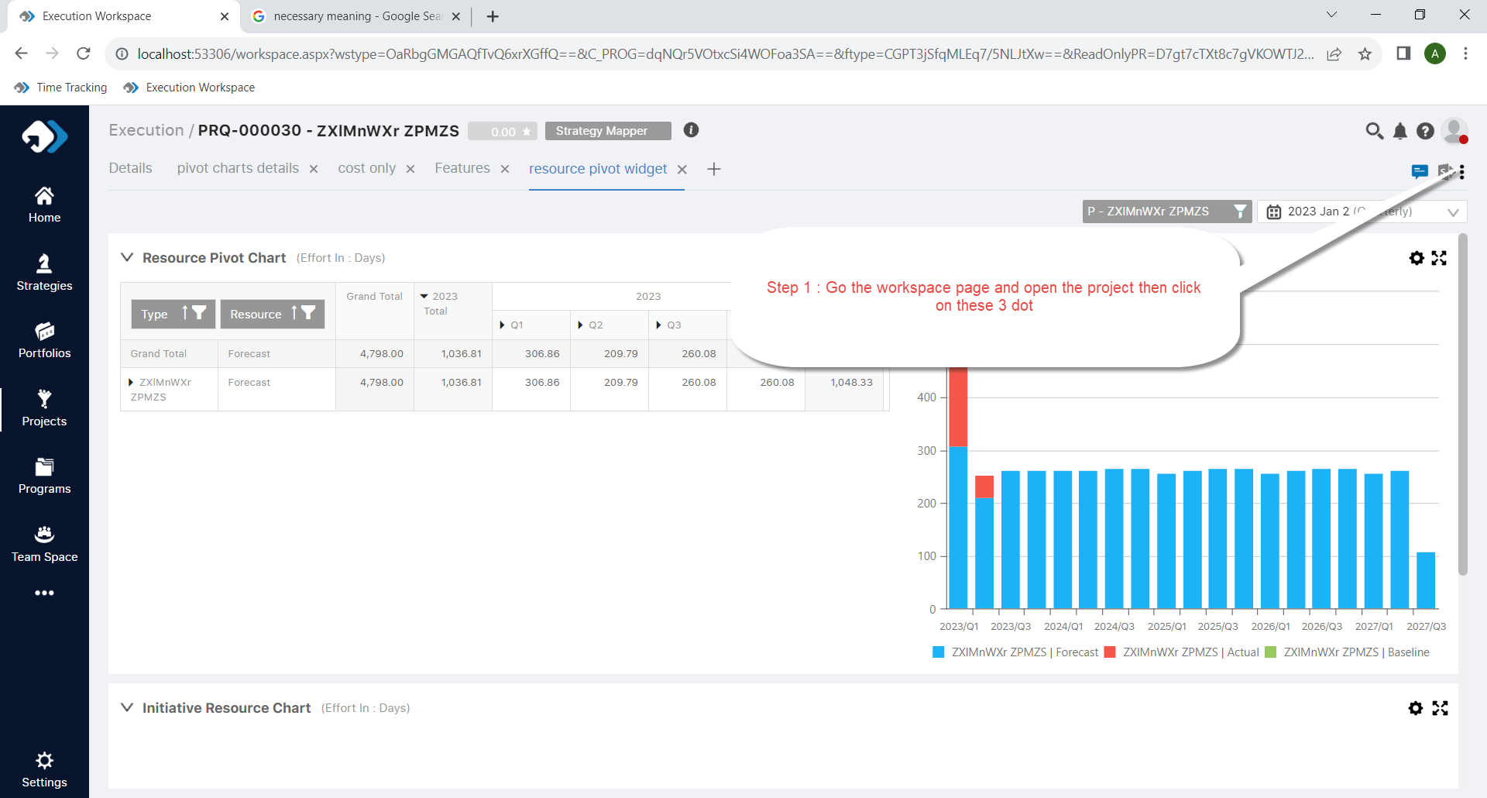

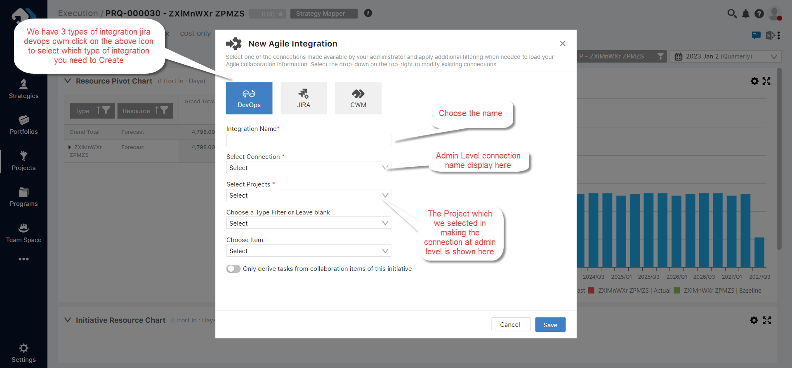

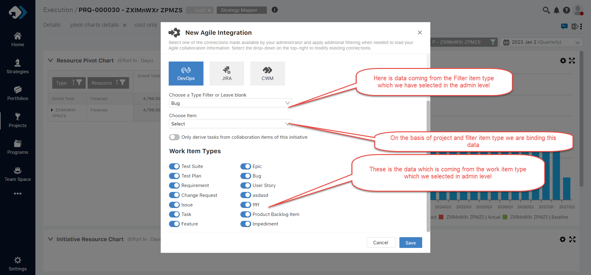

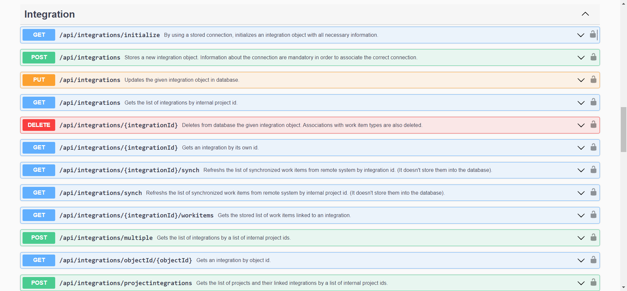

These all the api is consuming while making the integration through the connection

Now come to the code part where all the dropdown are binding

These is the popup page where all the dropdown are binding

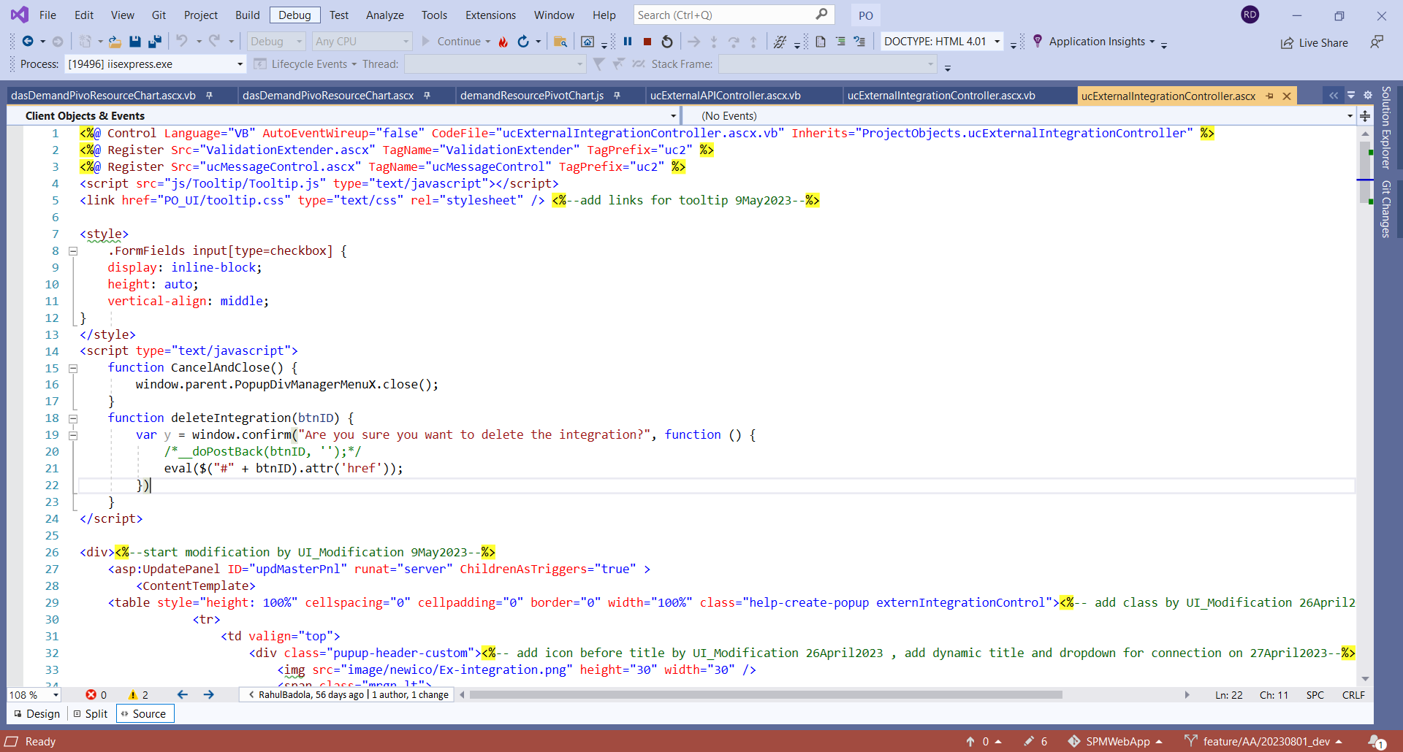

And all the data dropdown are binding from the vb side here is the vb side of the page where all the operation are perform

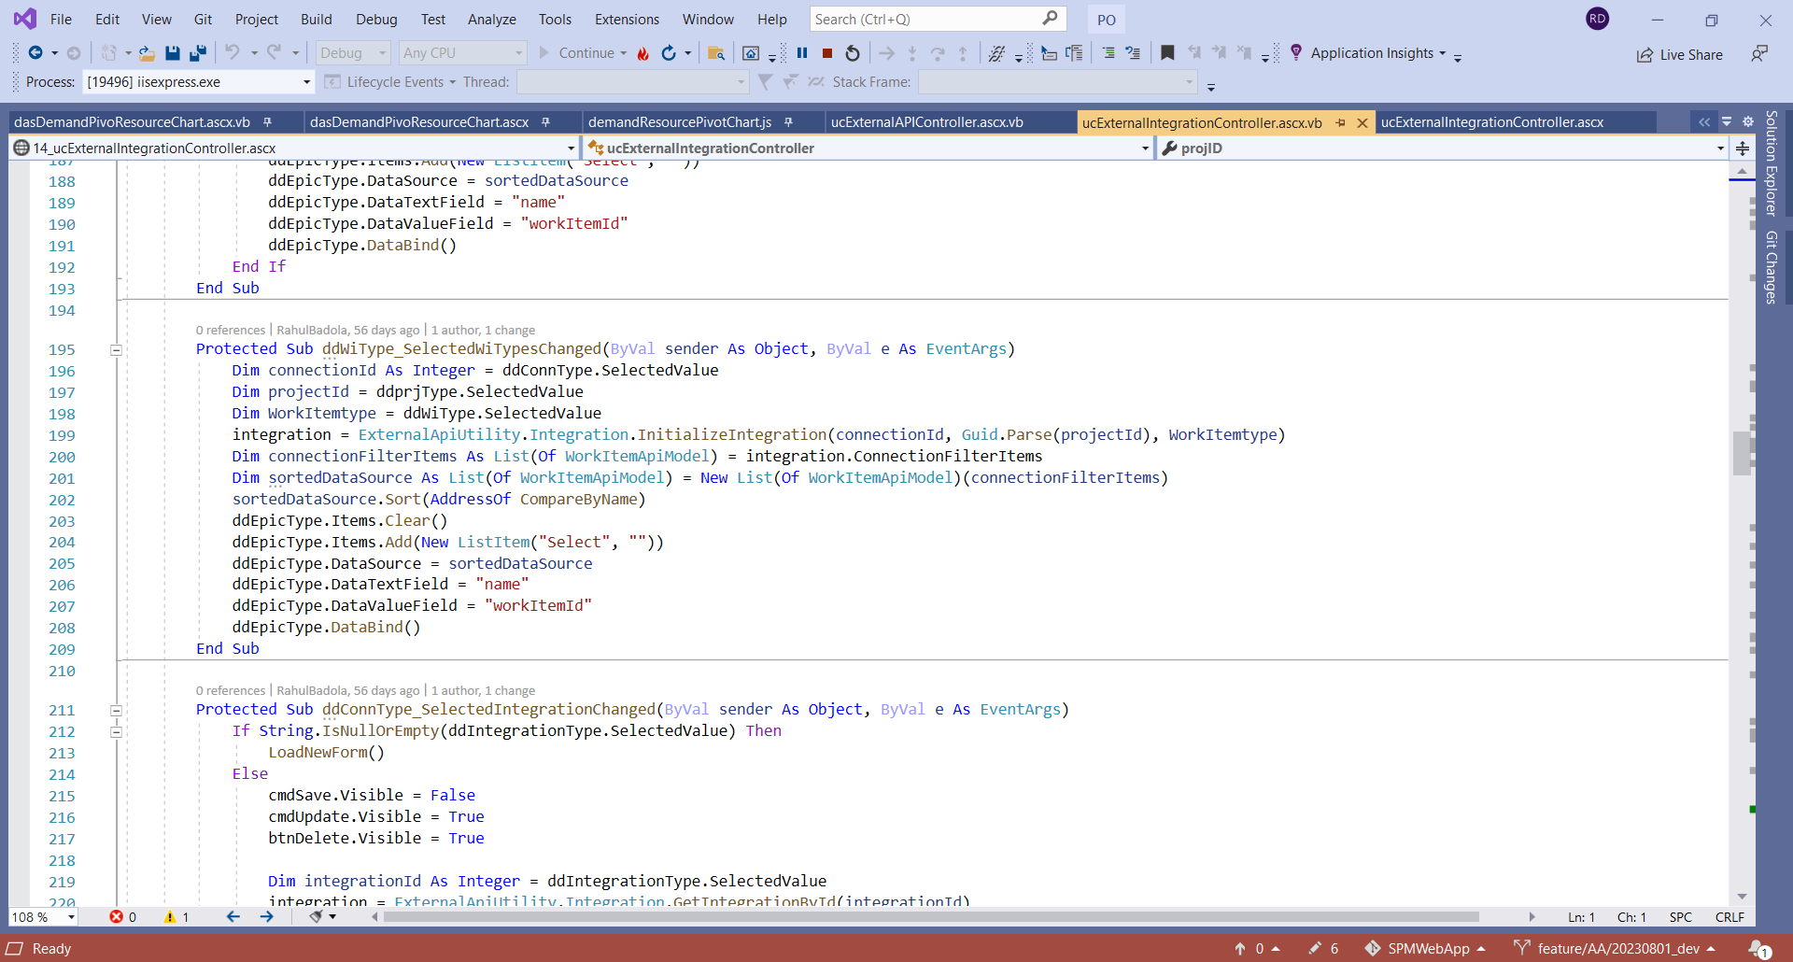

From here we are taking data from the api and binding that data in the dropdown

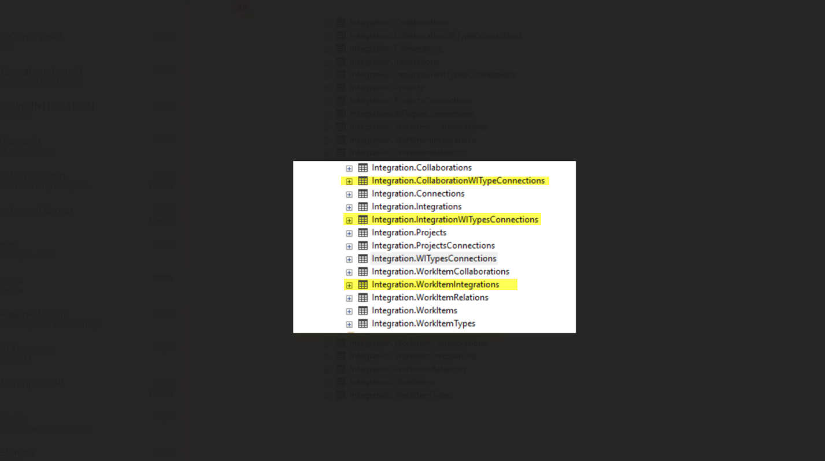

Data is saving in these table

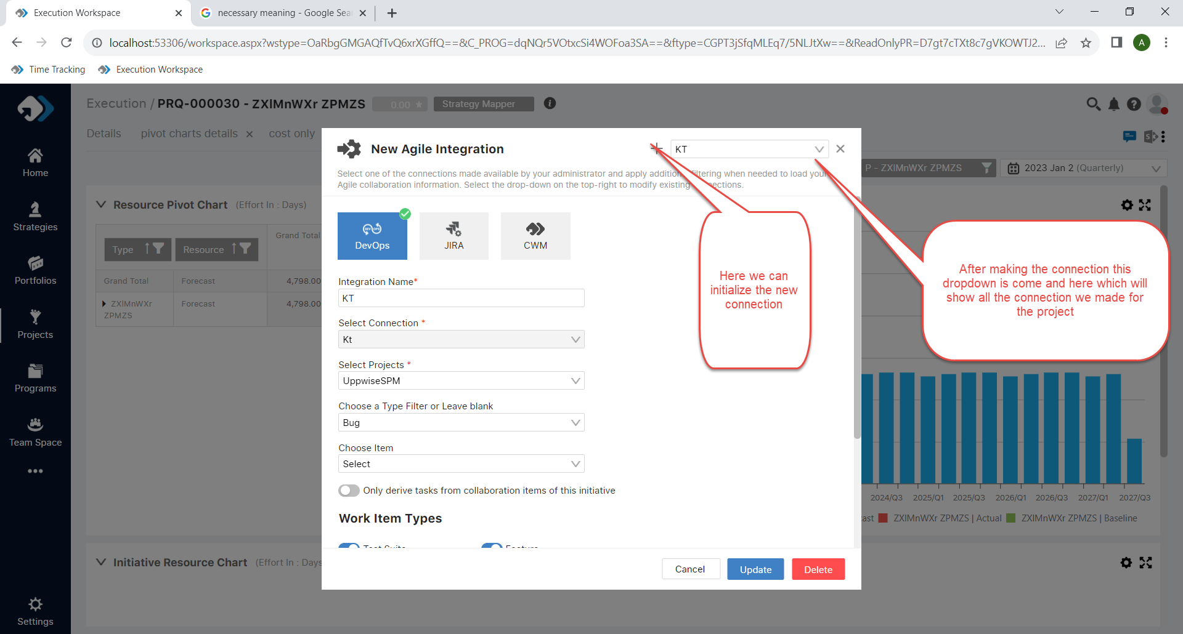

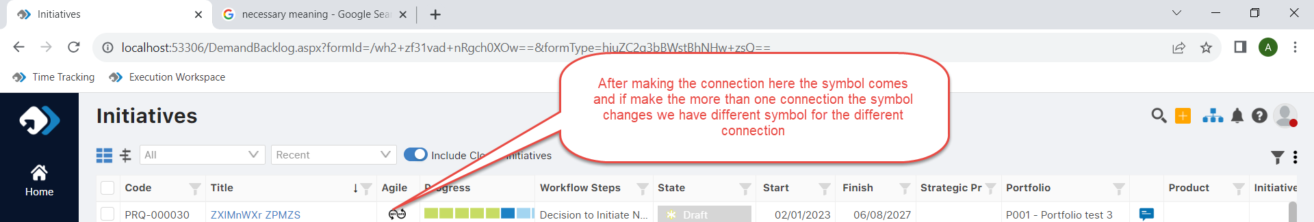

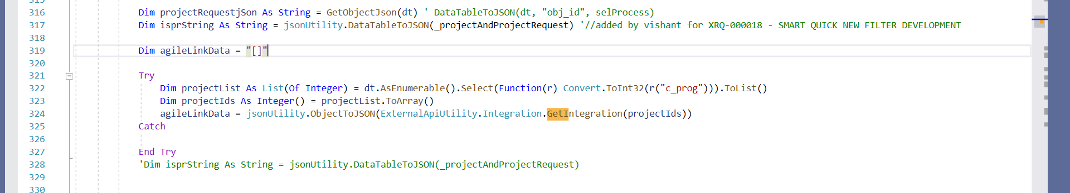

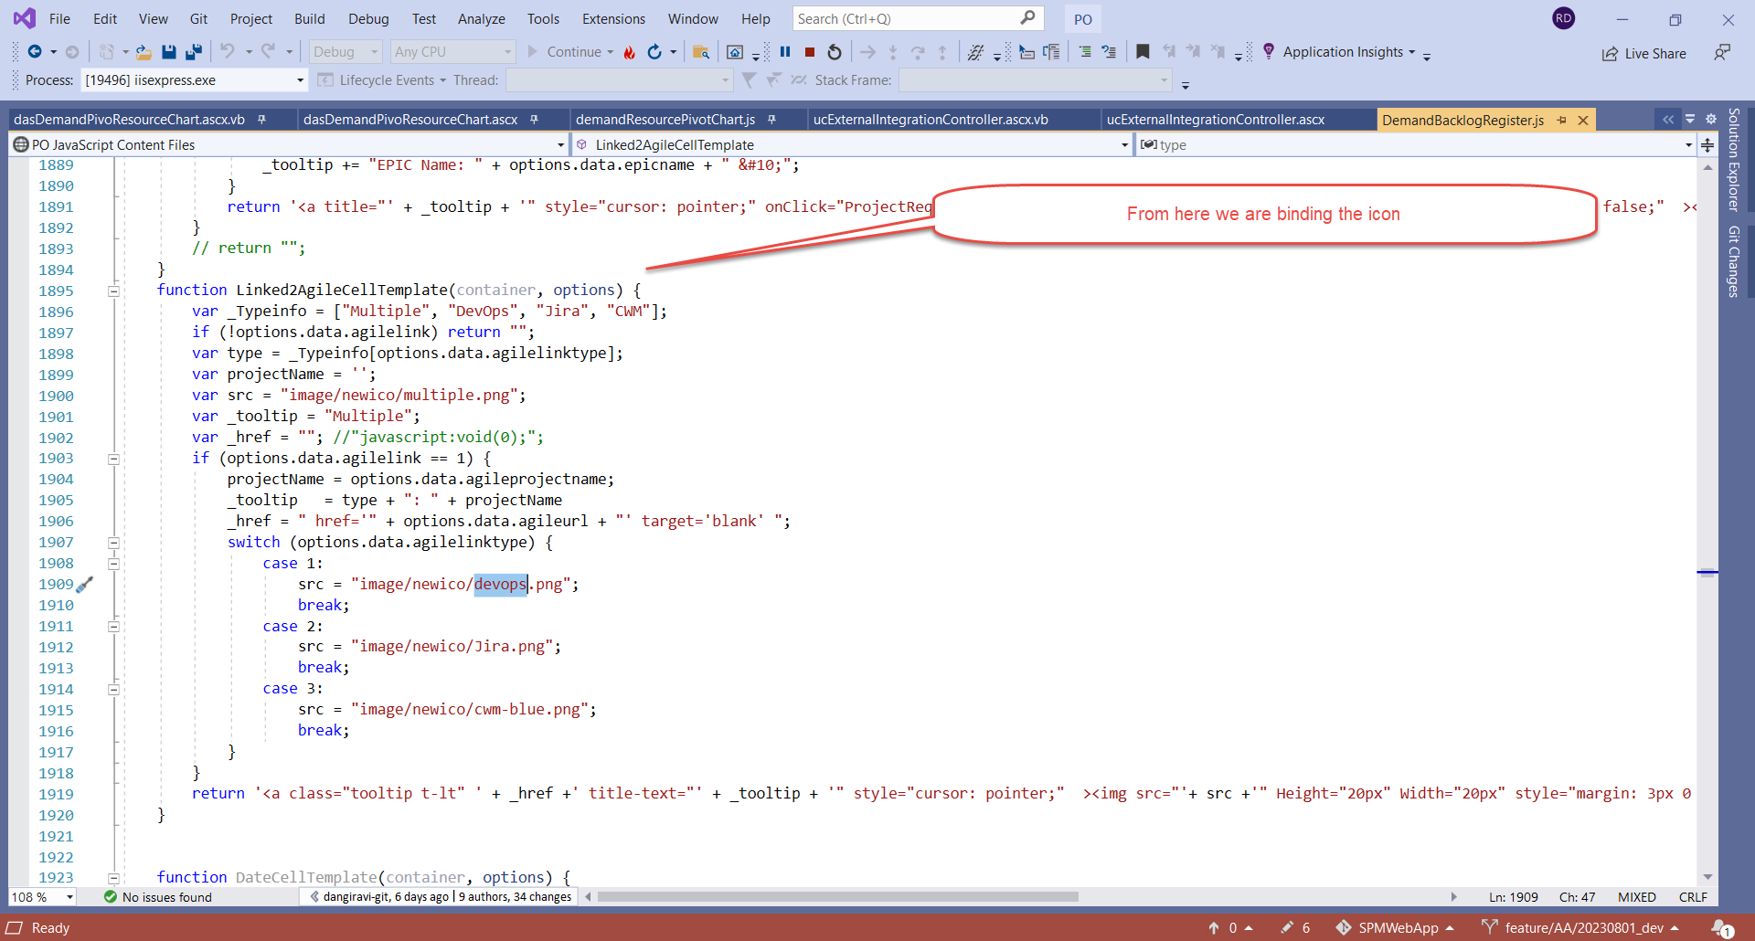

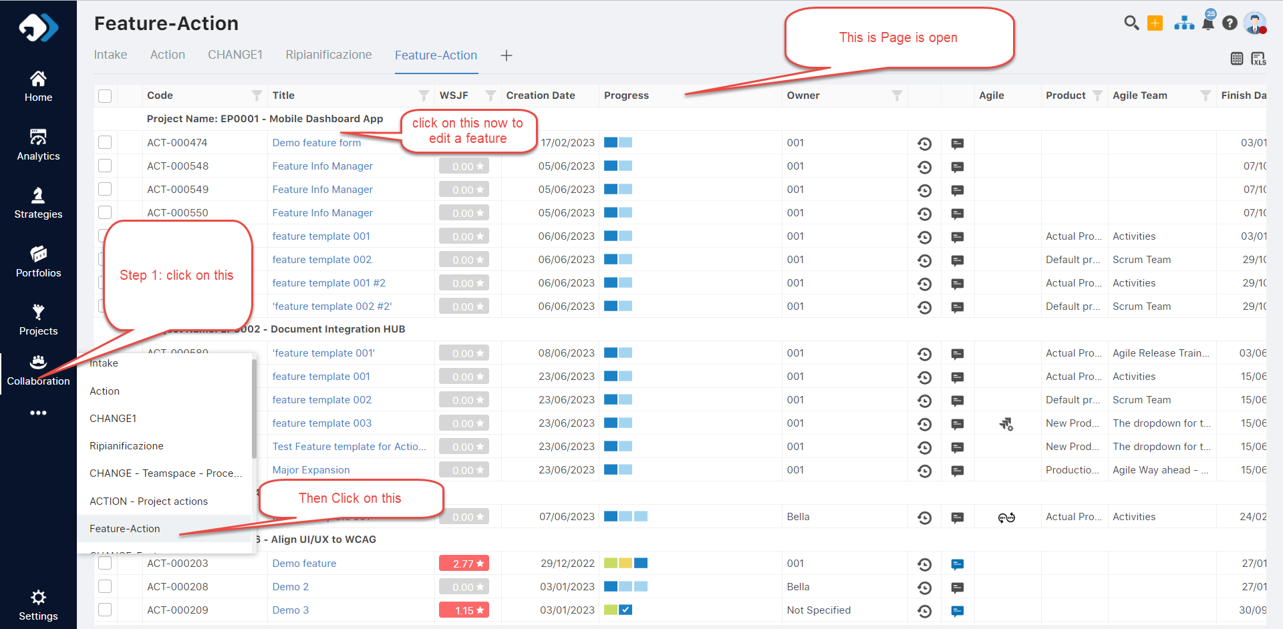

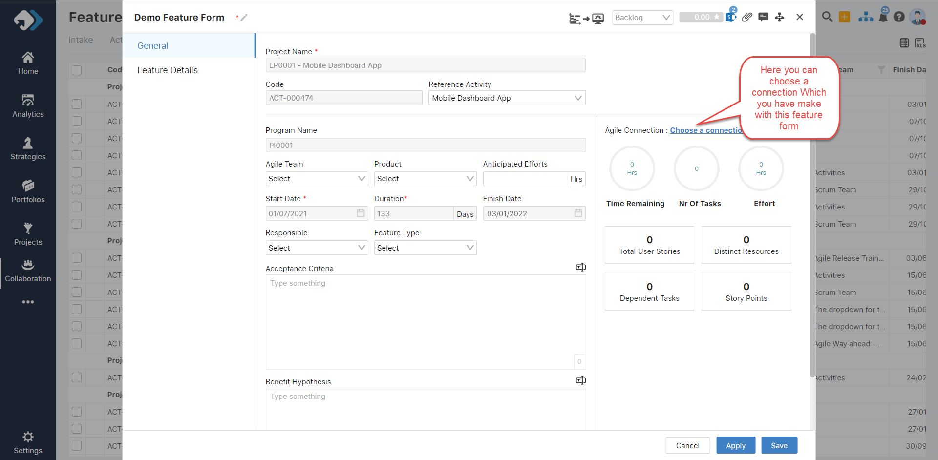

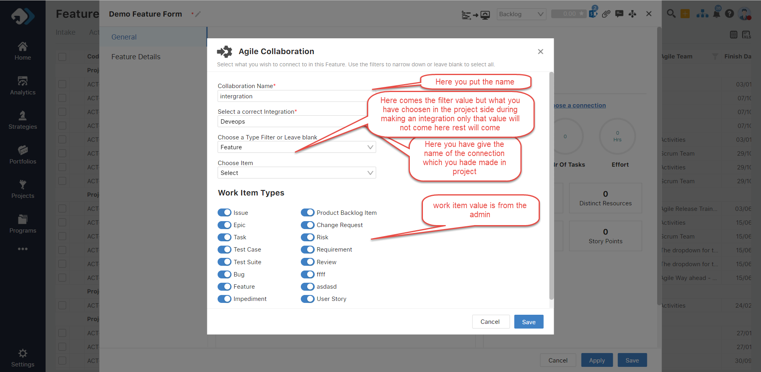

Now come to the code side

For collaboration we are consuming these api

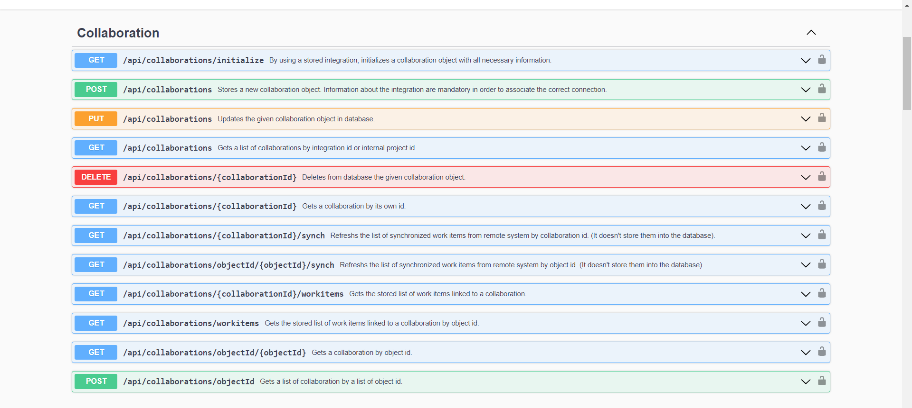

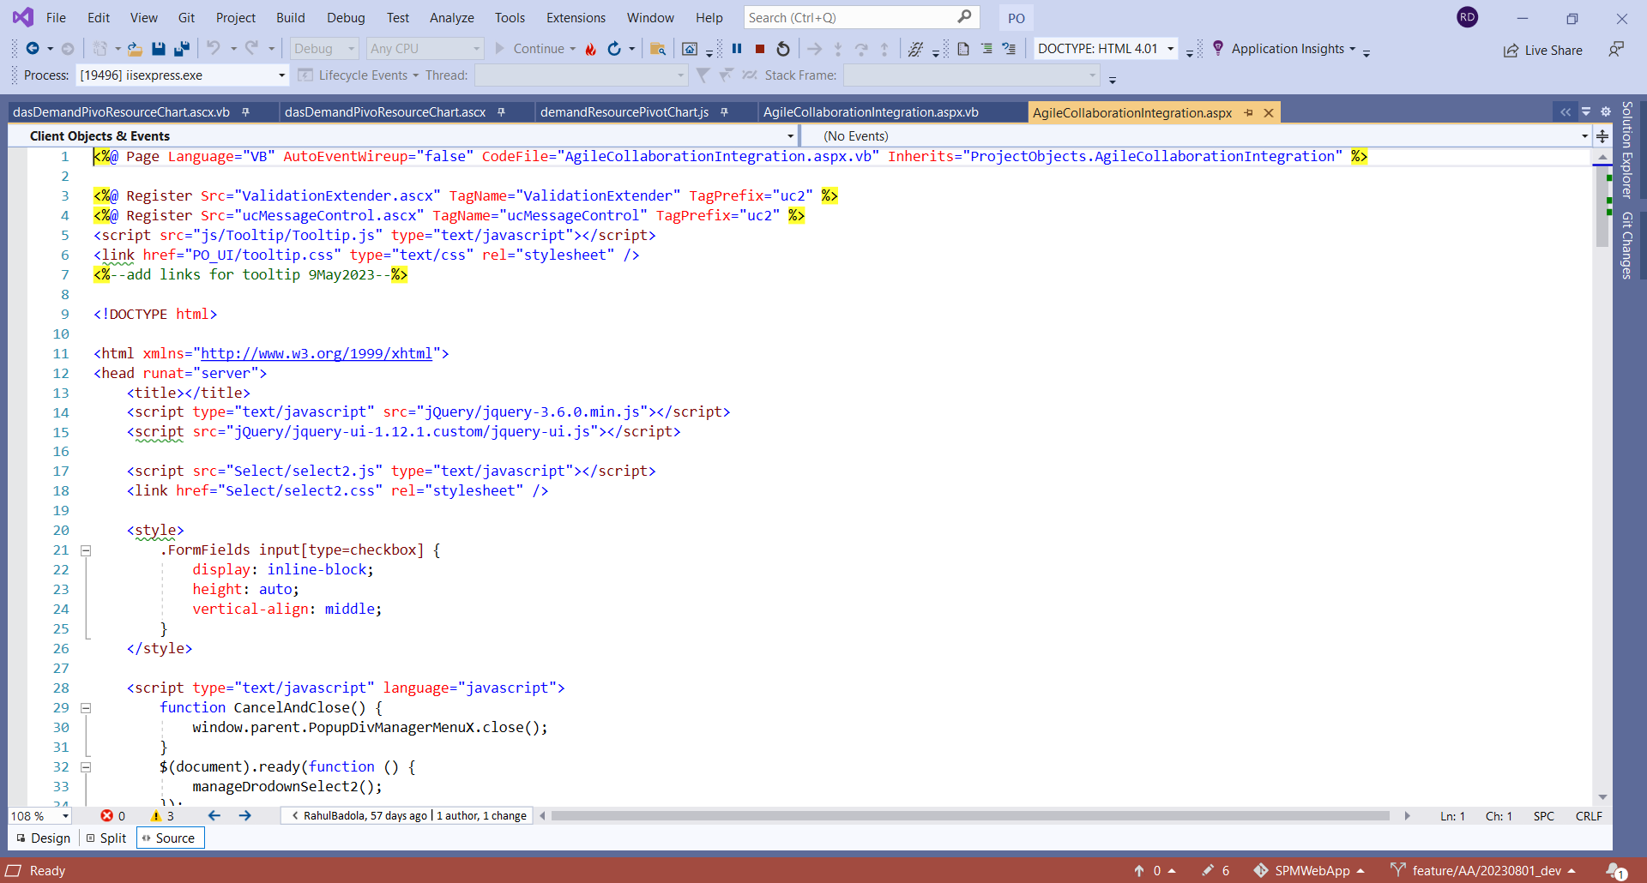

This is the page of the popup where all the data is binding like the dropdown and other value

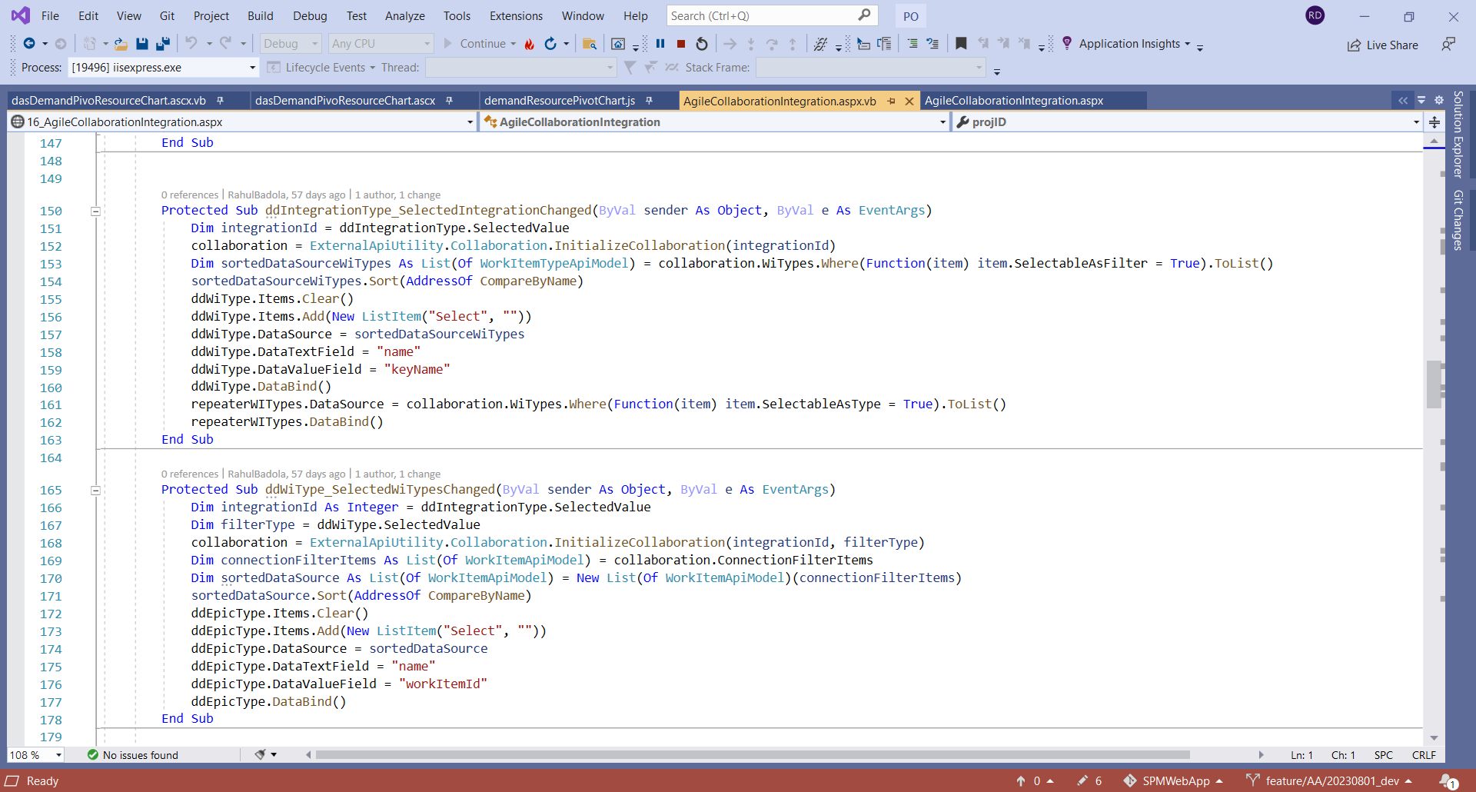

Here is the vb side where all the dropdown are binding and getting the value from the api

Here when we save the connection

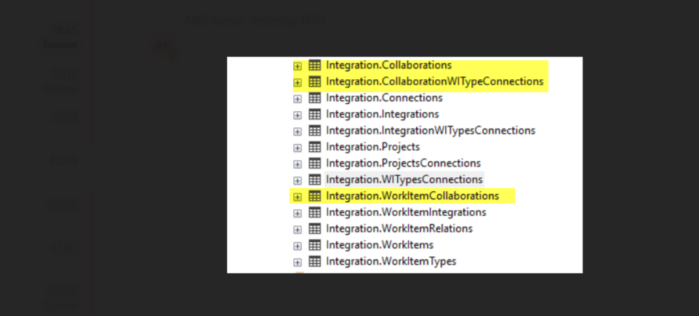

We are putting the entry in these fields

After making the connection this page appears

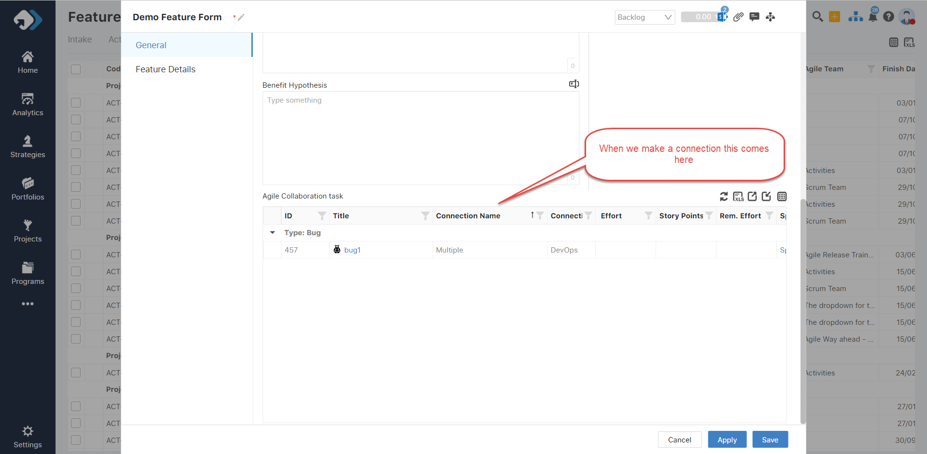

Now comes the code side from where we are binding the values

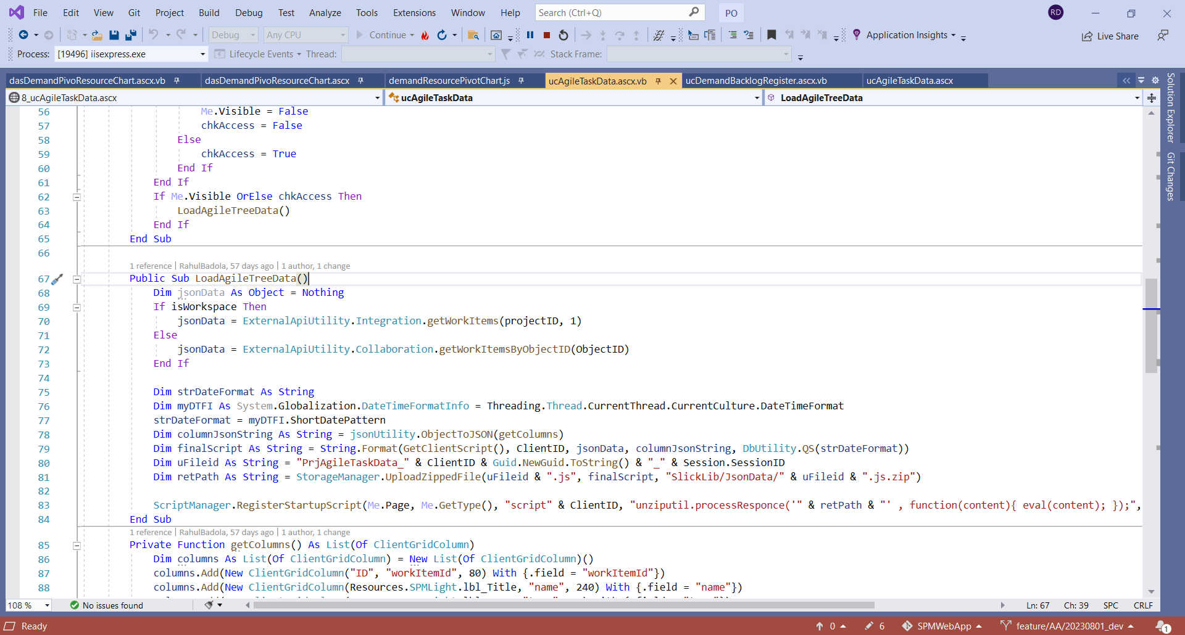

There is also a condition for binding as you see above on the basics of the workspace

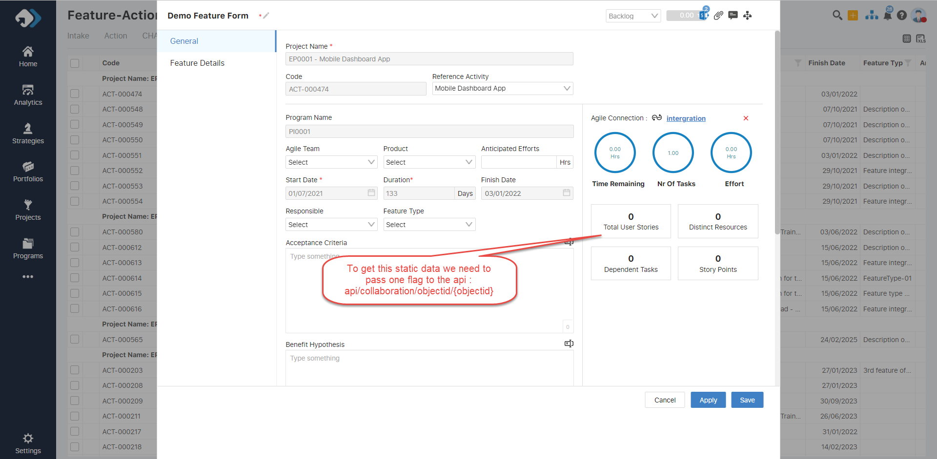

The flag which I am about is this

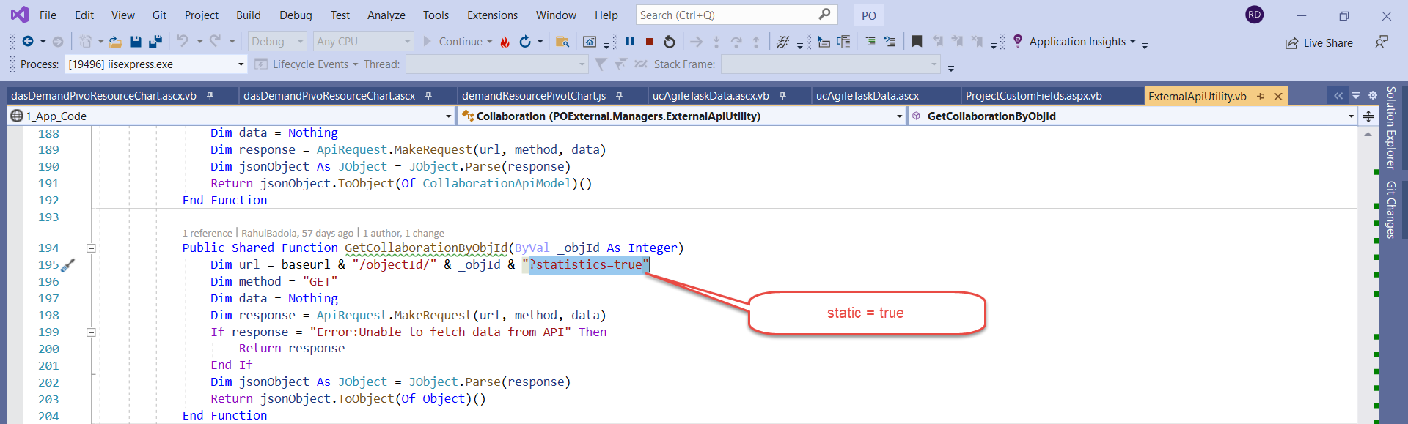

Agile IntegrationApi Development

The objective of this API is to seamlessly integrate DevOps, Jira, and CWM, consolidating them into a unified system. By doing so, it aims to streamline and harmonize the functionalities of these platforms, fostering a cohesive and interconnected environment. This integration facilitates a more efficient and collaborative workflow, allowing for a smoother exchange of data and processes between DevOps, Jira, and CWM. The API is designed to enhance overall system coherence and optimize the utilization of these diverse tools, promoting a more holistic approach to project management and development processes.

Here the Scehem which we have Use

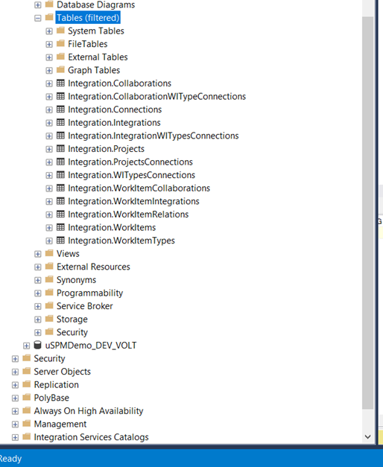

**Integration.Connections Table**:

Stores ConnectionId and ConnectionType.

ConnectionType values: 1 for DevOps, 2 for Jira, 3 for CWM.

Captures authentication details and URLs.

**Integration.Integrations Table:**

Records integrationId, connectionId, connectionType, and internalProjectId (SPMProjectId).

Manages project-level connections for Jira, DevOps, and CWM.

**Integration.WorkItemType Table:**

Contains WorkItemTypeID, connectionType, and keyname.

**WITypeConnections Table:**

Stores enable as type and enable as filter chosen at the connection level.

Links projects in the Integration.Projects table.

**WorkItemType Table:**

Associates keynames provided by the internal system with workItemTypeIds, linked to connectionIds.

**Integration.Projects Table:**

Holds projects categorized by Jira, DevOps, and CWM.

**Integration.WorkItems Table:**

Captures data at the project level, displayed in the widget upon saving.

Includes connectionType, workItemKey, and workItemId.

**WorkItemsIntegrations Table:**

Establishes relationships between workItemIds and integrationIds.

**Integration.WorkItemRelation Table:**

Records relations between workItems.

**IntegrationWITypeConnections Table:**

Manages project-level filters as types and enables them. Includes workItemTypeIds.

For collaboration:

**Integration.Collaborations Table:**

Establishes relations based on integrationId and objectId.

**CollaborationWITypeConnections Table:**

Stores enable as type, filter as type, and collaboration, similar to the project, but with a collaboration id.

**SPM Integration API Overview:**

**1.Entry Point: SPM.Integration.API**

This project serves as the entry point, orchestrating the integration process. It references the .NET Standard 2.0 framework and acts as a bridge between the business layer API and the integration modules.

**2. SPM.Integration.ApiModels**

This project, written in the .NET Standard 2.0 framework, contains essential API models. It includes classes and namespaces that form the foundation for data transformation within the integration solution.

**3. SPM.Integration.Console**

This module provides a console interface for interaction with the integration system. It serves as a user-friendly entry point for initiating and monitoring integration tasks.

**4. SPM.Integration.Interfaces**

The interfaces project defines the contract for integration components, promoting code consistency and modularity. It acts as a bridge between different modules, ensuring seamless communication.

**5. SPM.Integration.Models**

Within this project, the spm.integration.models namespace is central to the integration process. Key components include:

Enums: SourceType.cs, RelationType.cs, etc.

JSON Models: Tailored for DevOps, Jira, and CWM integrations.

Client Implementations: JiraIntegrationClient.cs, CWMIntegrationClient.cs, DevOpsIntegrationClient.cs.

Integration Logic:

Enums facilitate categorization.

Helper functions enhance data transformation.

Unified authentication approach using a consistent token from the business layer API ensures security.

Controllers:

The integration module includes controllers that manage different aspects:

ConnectionController: Manages connections with a focus on the WorkItemTypes functionality.

DBConnectionController: Handles database connections.

CollaborationController: Orchestrates collaboration-related tasks.

ProjectController: Manages project-related functionalities.

Transformation Process:

The transformation process involves transitioning from the model factory to the model. This enhances coherence and clarity in data handling within the integrated systems.